**Energy General Allocation Predictor**

A project by AJMLS for #BlueHacks2017

Overview:

* Language consists of Python for the model and Java for the UI
* Implements Recurrent Neural Networks (a subset of Machine Learning) to predict the global energy consumption using a trained dataset.
* Dataset consists of the global consumption of coal, reserves, natural gas, and oil from 1973 to 2014.

Objectives:

* The goal of the project is to help the users to monitor their consumption of resources and foresee the consequences before they use too much.
* To spread awareness on energy consumption so that people can be more responsible when using resources.
* Fights for one of the Global Goals of Sustainable Development set by the United Nations: 12 – Responsible Consumption and Production.

Usage:

1. Enter the starting year as your basis (2014 being the lowest, 2050 being the highest)
2. Enter the range of years you plan to observe (1 lowest, 50 highest)
3. Press “Predict”

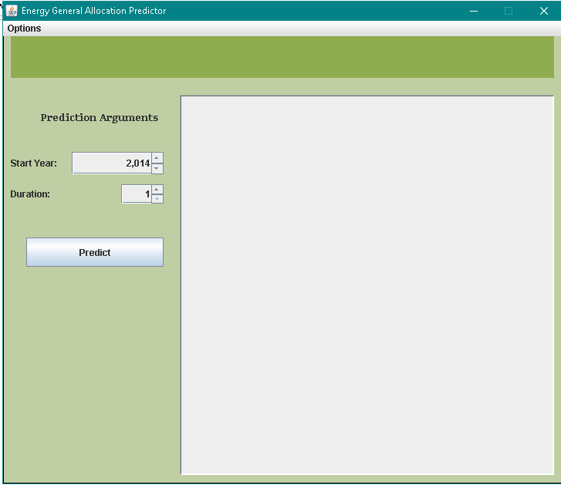

Sample Usage:

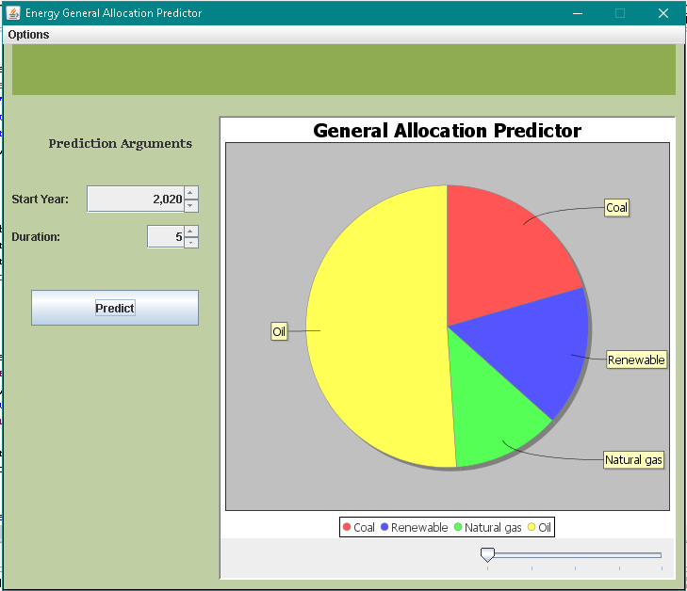

A slider that you can drag to see the results of the duration you specified

About (found under the Options tab):

